ST-1 Summary

ST-1 Test Stats | #
Test cases planned for this sprint | 2
Test cases COMPLETED (without errors) | 2 | WHICH FR? | FR 4.1  FR 5.4
Test cases NOT COMPLETED | 0 | WHY?
DEFECTS found | 2 | STATUS: | Open

FR 4.1
STP Test Case # ST-1
Requirement tested: FR-4.1
Determination: SUCCESSFUL

Setup:
- Open Chrome browser on Windows OS
- Navigate to front-facing Moxie server (http://moxie.cs.oswego.edu:7000/)
- Execute test

Execution:
- Navigate to weekly report form.
- Leave at least one required field empty.
- Attempt to submit the report.
- Return to the Student Home Page.
- Observe report status.

Expected Result:
The system shall check all required weekly report fields upon submission. If any required field is missing, empty, or null, the system shall detect the missing input and trigger a validation response before allowing submission.

Screenshot:
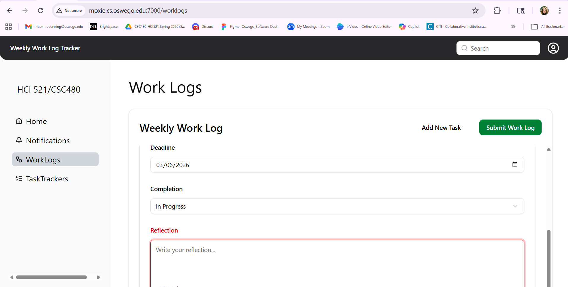

FR 5.4
STP Test Case # ST-1
Requirement tested: FR-5.4
Determination: SUCCESSFUL
Setup:
1. Open Safari browser on MacOS.
2. Navigate to the front-facing Moxie server
(http://moxie.cs.oswego.edu:7000/)
3. Log in as a student user.
4. Generate a notification by adding a task or submitting a report.
Execution:
- Navigate to the Student Home Page.
- Locate the notification section on the home page.
- Observe the notifications displayed.
- Click View More to navigate to the Notifications page.
- Compare the notifications shown on the home page with those on the Notifications page.
Expected Result:
The system shall display generated notifications on the user's home page in the notification section. The notifications displayed on the home page shall match the notifications shown on the Notifications page when the user selects View More.
Screenshot:
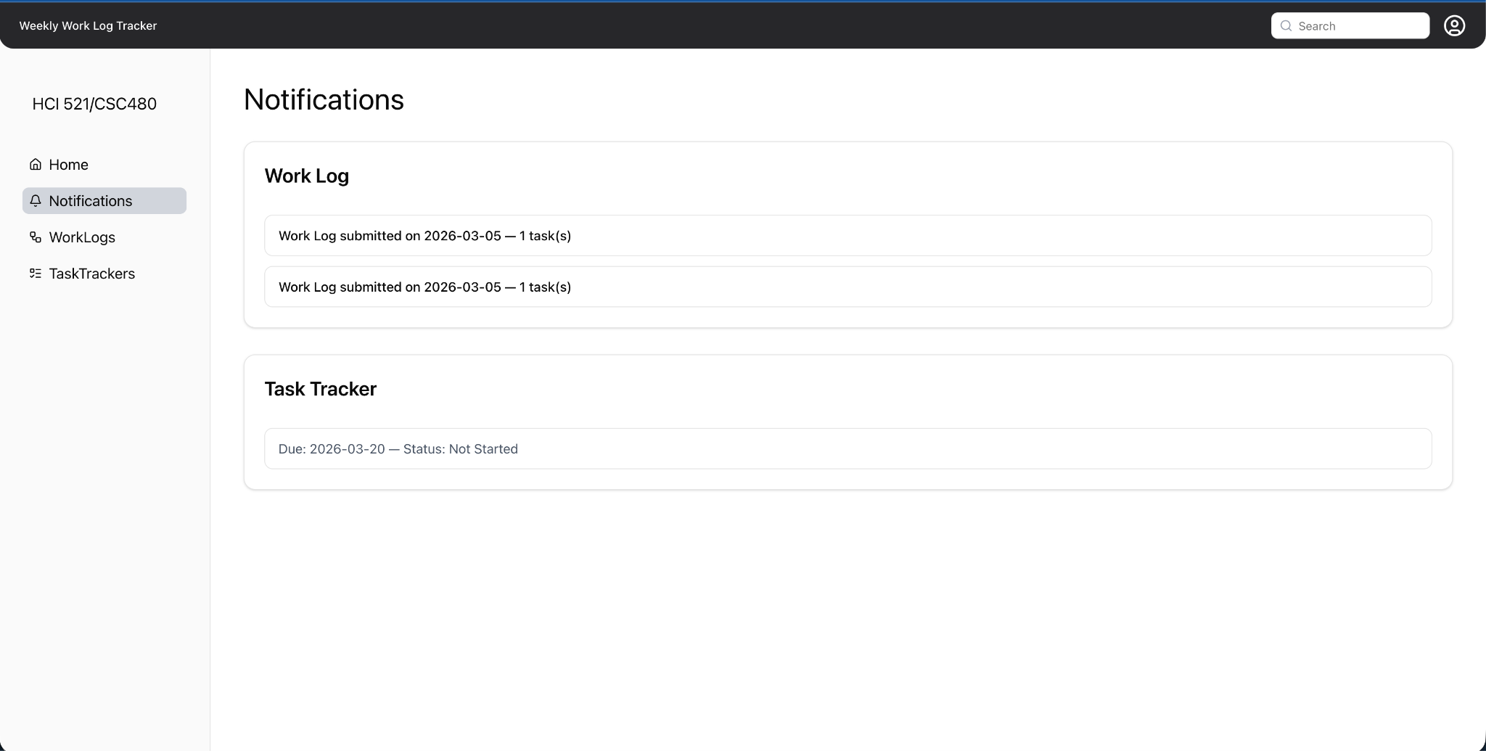

ST-1 BUGS
Bug/Defect # Defect-1

Severity: Low

STP Test Case # ST-1

Build/Release # v0.1.0_20260304

Steps during test:
- Open Chrome browser on Windows OS
- Navigate to Homepage on Moxie website
- Clicked on Continue this week’s worklog button
- Navigated to worklog page
- Filled in sample data leaving the reflection field blank
- The system successfully gave error feedback (Red color of text field, and red “Reflection” indicator
- The worklog page was not scrollable.

Description:
During FR-4.1/ST-1, we found that we can’t scroll entire page but the Weekly worklog section is scrollable.

Potential Cause (if known):
Not sure, could be related to sizing or Windows/Chrome conversion

Screenshots of errors:



—----------------------------------------------------------------------------------------------------------------------------

Bug/Defect # Defect-2
Severity: Critical

STP Test Case # ST-1

Build/Release # v0.1.0_20260304

Steps during test:
- Open Chrome browser on Windows OS
- Navigate to Homepage on Moxie website

Description:
During ST-1, Mac OS (Safari browser) was successful loading homepage and worklog page
Windows OS (Chrome browser) was sometimes successful. The Moxie server became unreachable and unreliable to continue testing.

Potential Cause (if known):
Moxie server unreachable/unreliable in Chrome on Windows OS

Screenshots of errors:
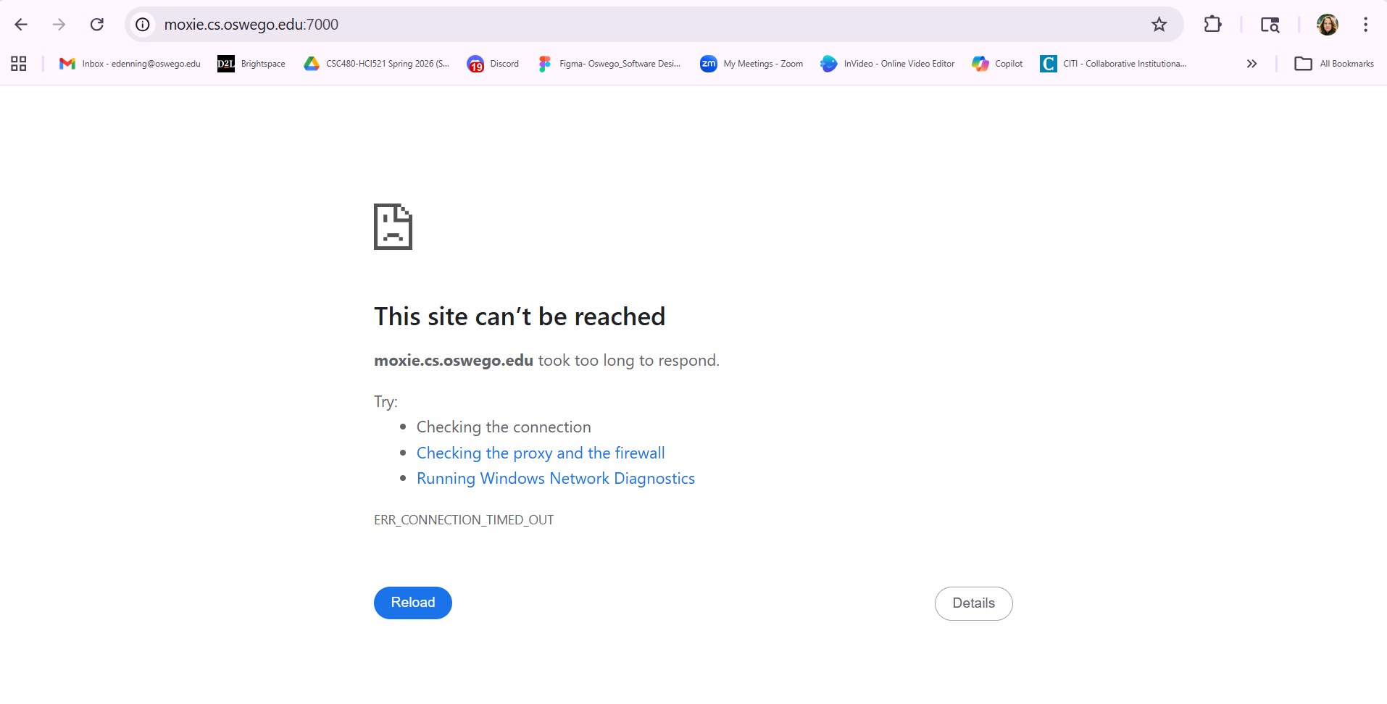
Homepage
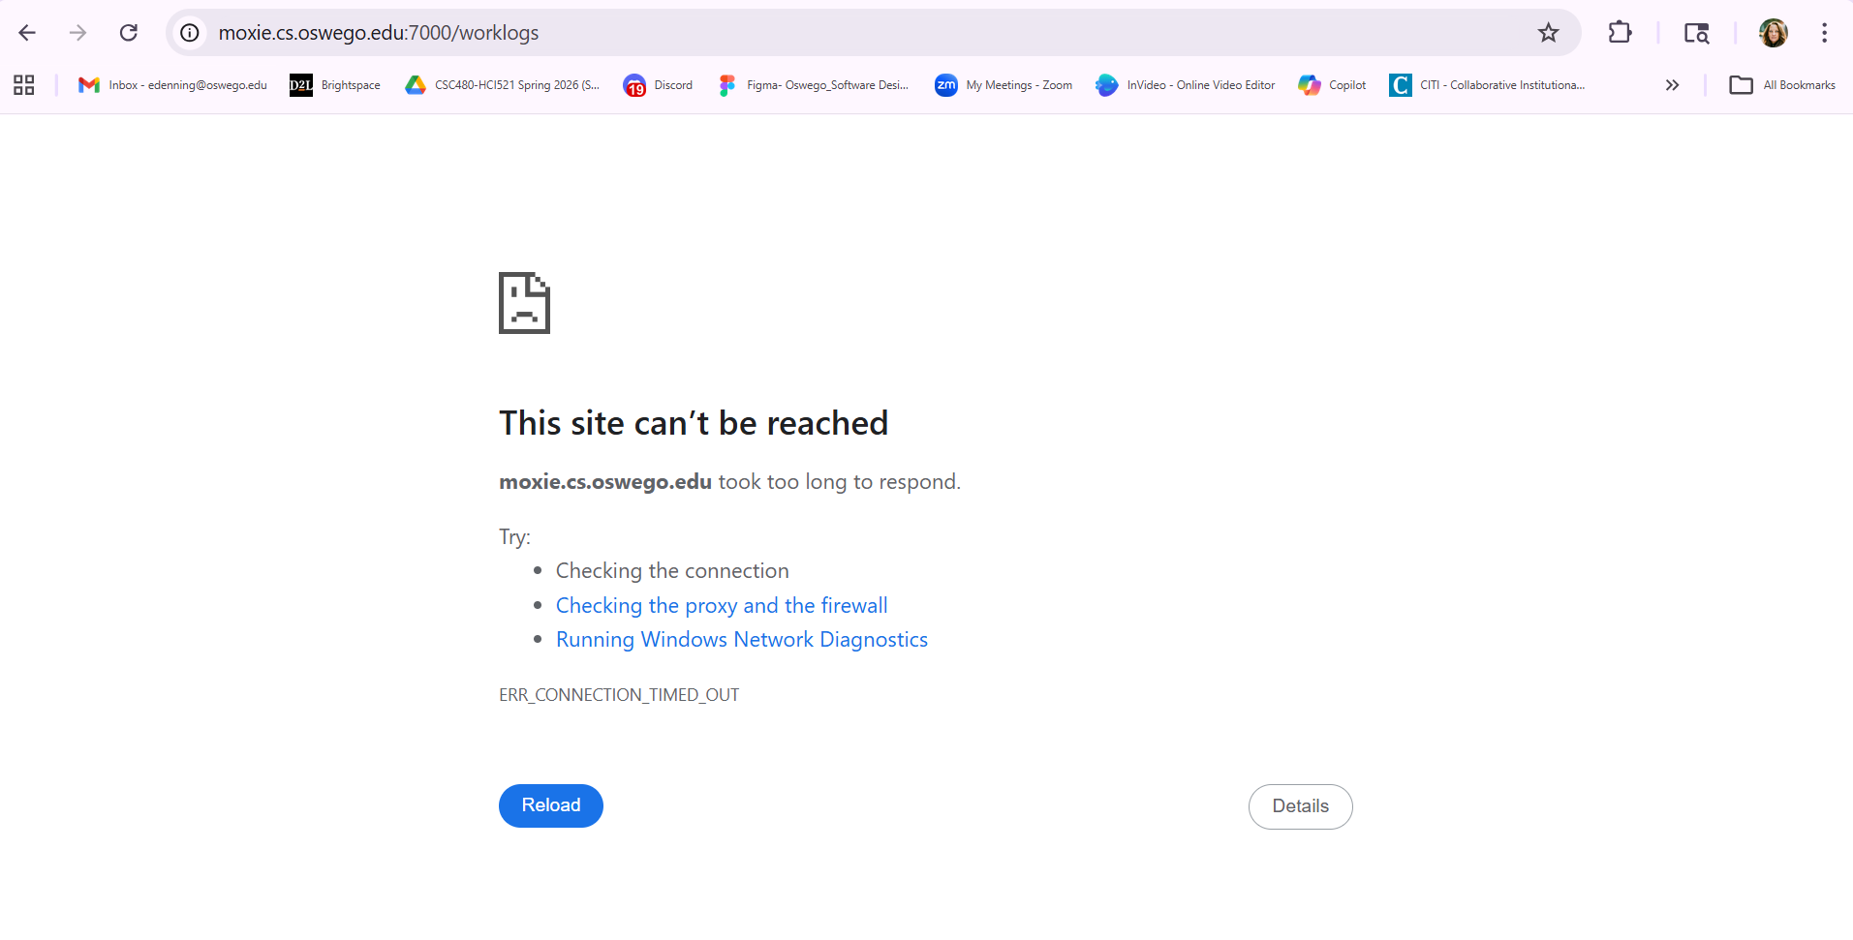
Worklogs page

—----------------------------------------------------------------------------------------------------------------------------

